LETTERKENNY INSTITUTE OF TECHNOLOGY

ASSIGNMENT COVER SHEET

**Lecturer’s Name:**  Ruth Lennon

**Assessment Title:**  Lab 1: Maven

**Work to be submitted to:**  Ruth Lennon

**Date for submission of work:**  12 January 2016

**Place and time for submitting work:**

To be completed by the Student

**Student’s Name:**  Dietmar Steiner

**Class:**  B.Sc (Honours). in Computer Science

**Subject/Module:**  Cloud/Enterprise Application

**Word Count (where applicable):**  N/A

**I confirm that the work submitted has been produced solely through my own efforts.**

**Student’s signature: Date:**  12/2/2016

|  |
| --- |
| **Notes**  **Penalties:** The total marks available for an assessment is reduced by 15% for work submitted up to one week late. The total marks available are reduced by 30% for work up to two weeks late. Assessment work received more than two weeks late will receive a mark of zero. [Incidents of alleged plagiarism and cheating are dealt with in accordance with the Institute’s Assessment Regulations.]  **Plagiarism:** Presenting the ideas etc. of someone else without proper acknowledgement (see section L1 paragraph 8).  **Cheating:** The use of unauthorised material in a test, exam etc., unauthorised access to test matter, unauthorised collusion, dishonest behaviour in respect of assessments, and deliberate plagiarism (see section L1 paragraph 8).  **Continuous Assessment:** For students repeating an examination, marks awarded for continuous assessment, shall normally be carried forward from the original examination to the repeat examination. |
|  |

# Aims/Description

The aim of the lab is to install maven and create a java project using maven artifacts

# Method

1. On the target machine no jdk was installed so I downloaded the latest JDK from [www.oracle.com](http://www.oracle.com) and installed under windows.
2. The The maven binaries zip file was downloaded from maven.apache.org and extracted into X:\CEA\rootproject\labs\lab1-maven\Lab1\apache-maven-3.3.9 .
3. The path environment variable was ammended using the command line: set PATH=%PATH%;"X:\CEA\rootproject\labs\lab1-maven\Lab1\apache-maven-3.3.9\bin" to include the maven binaries.
4. The JAVA_HOME environment variable was created using the command line: set JAVA_HOME=C:\Program Files\Java\jdk1.8.0_73.
5. The command mvn –version was run with the following result:  
   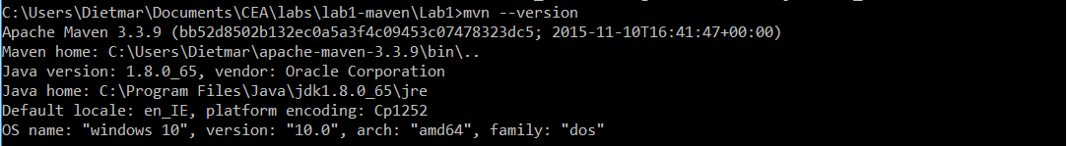
6. mvn -archetype:generate -DgroupId=mvnApps -DartifactId=ie.lyit.mvntest -DarchetypeArchtifactId=MvnTest maven-archetype-quickstart -DinteractiveMode=false   
   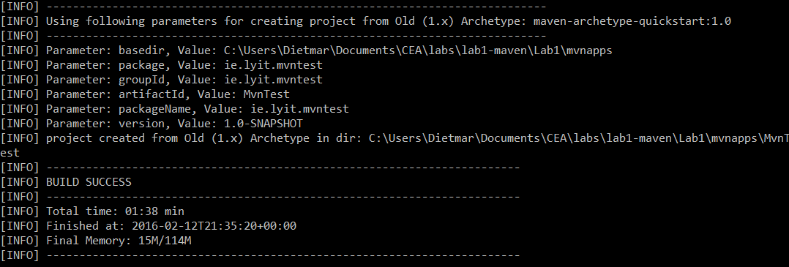
7. Then the the new project was built using mvn package   
   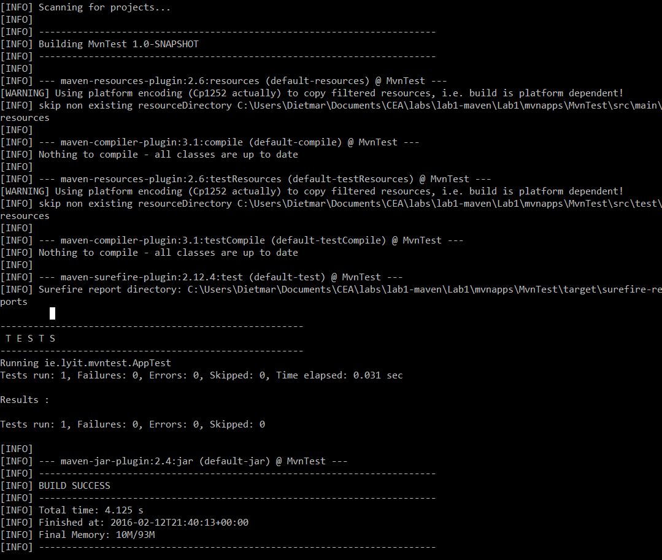.
8. The generated jar was then tested with java –cp .\mvnapps\MvnTest\target\MvnTest-1.0-SNAPSHOT.jar ie.lyit.mvntest.App  
   
9. The generated directory tree structure was as expected:  
   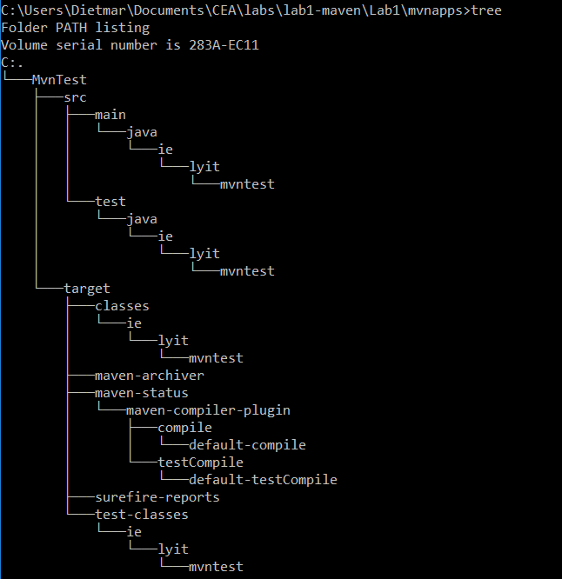

# Results

Mvninit.bat was created to automate the recurring task of setting up the working environment of maven.

mvninit.bat:  
set PATH=%PATH%;"X:\CEA\rootproject\labs\lab1-maven\Lab1\apache-maven-3.3.9\bin"  
set JAVA_HOME=C:\Program Files\Java\jdk1.8.0_73

Code: mvninit.bat

Mvnsetup.bat was created to ease setup of new projects.  
Using the command line parameters are used for setting up the Base directory, the new application directory and the Main class for the created project.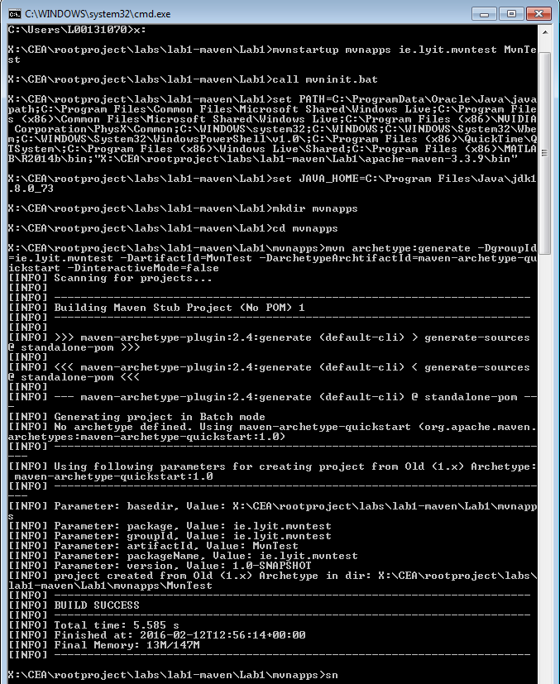  
mvnsetup.bat:

call mvninit.bat  
mkdir %1  
cd %1  
mvn -archetype:generate -DgroupId=%2 -DartifactId=%3 -DarchetypeArchtifactId=maven-archetype-quickstart -DinteractiveMode=false  
cd %3  
mvn package

# Conclusions

The installation of maven did not present any problems following the instructions of the lab description.

A batch file was created to set the environment variables needed to run maven.

The setup of a new project did not present any problems using the instruction in the lab description.

A batch file was created to automate the setup of a new project using command line parameters for variable parameters of the setup and compile the generated project for verification that the generated project does compile and run the tests successfully.

Mavens advantage over other is the inclusion of a repository of libraries which are scanned and downloaded as maven progresses through the build process.

Build tools in general ease the burden of knowing every step of the build process and save a lot of time. If build on another system maven can be setup to download the required source from a revision control system and download all the dependencies from its repository.

# References& Bibliography